Case 2-ME-Syria-Tel Halaf-Fertility Idol-Terracotta--6000-5400 BCE
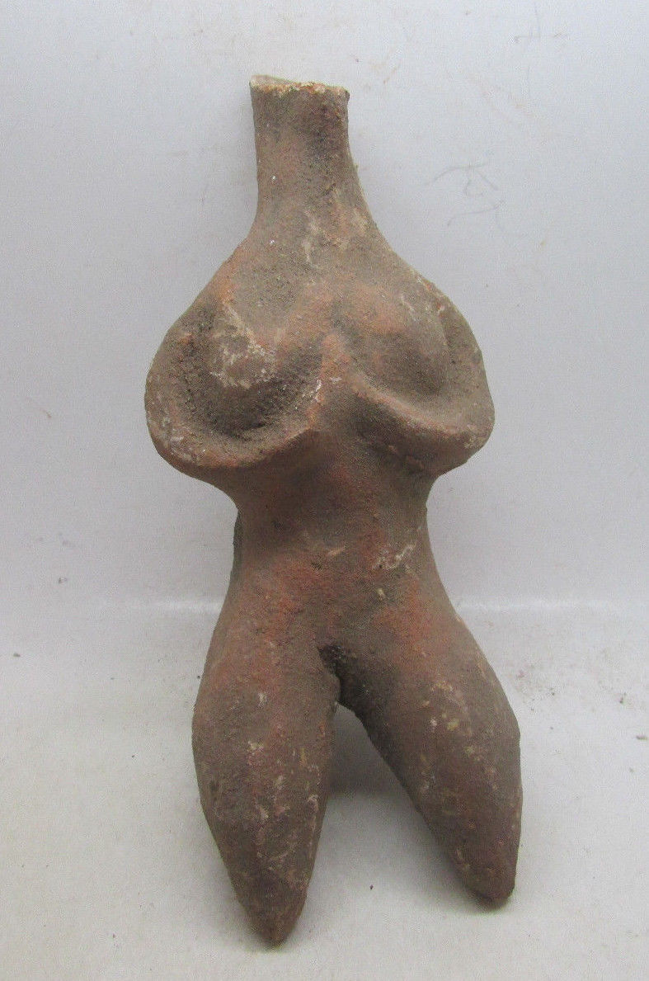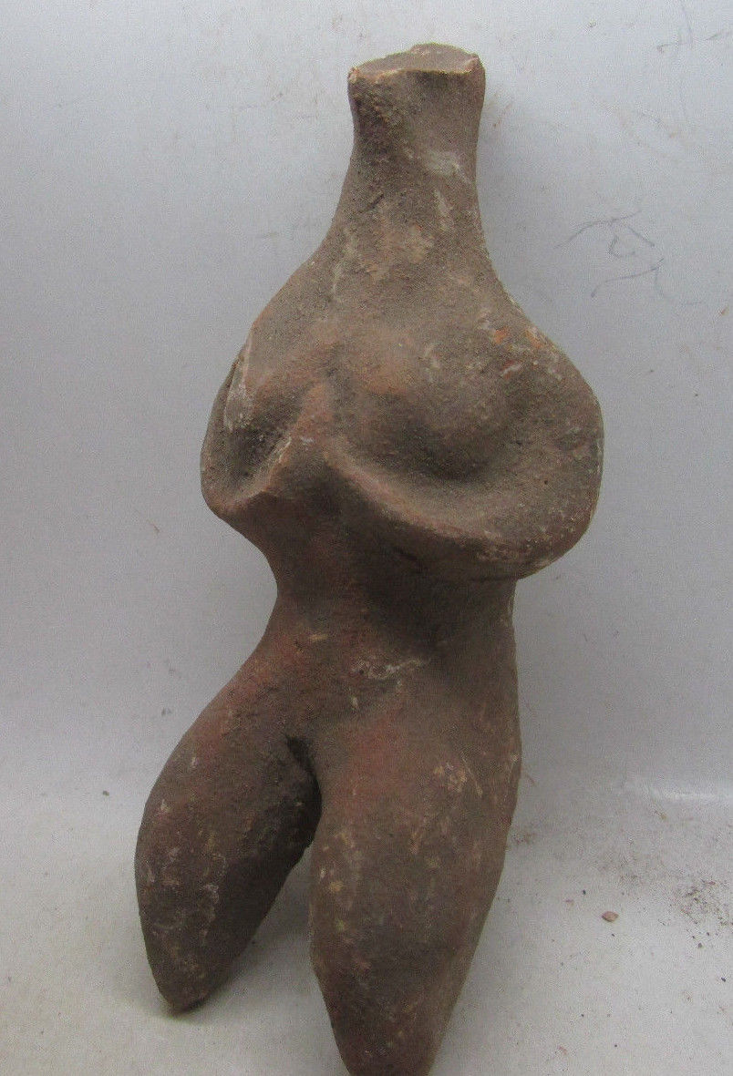
Case no.: 2
Accession Number:
Formal Label: Syria-Tel Halaf-Fertility Idol-Terracotta--6000-5400 BCE

Display Description:
Tell Halaf (Arabic: تل حلف‎) is an archaeological site in the Al Hasakah governorate of northeastern Syria, near the Turkish border, just opposite Ceylanpınar. It was the first find of a Neolithic culture, subsequently dubbed the Halaf culture, characterized by glazed pottery painted with geometric and animal designs. The site, which dates to the 6th millennium BCE, was a Hittite ruling city at first and was later the location of the Aramaean city-state of Guzana or Gozan in the 10th century BCE. By the end of 9th century BCE the city and its surrounding area was incorporated into the Assyrian Empire.
The Halaf culture is a prehistoric period which lasted between about 6100 BCE and 5100 BCE.^{[1]} The period is a continuous development out of the earlier Pottery Neolithic and is located primarily in south-eastern Turkey, Syria, and northern Iraq, although Halaf-influenced material is found throughout Greater Mesopotamia.
While the period is named after the site of Tell Halaf in north Syria, excavated by Max von Oppenheim between 1911 and 1927, the earliest Halaf period material was excavated by John Garstang in 1908 at the site of Sakce Gözü, then in Syria but now part of Turkey.^{[2]} Small amounts of Halaf material were also excavated in 1913 by Leonard Woolley at Carchemish, on the Turkish/Syrian border.^{[3]} However, the most important site for the Halaf tradition was the site of Tell Arpachiyah, now located in the suburbs of Mosul, Iraq.^{[4]}
The Halaf period was succeeded by the Halaf-Ubaid Transitional period which comprised the late Halaf (c. 5400-5000 BC), and then by the Ubaid period.
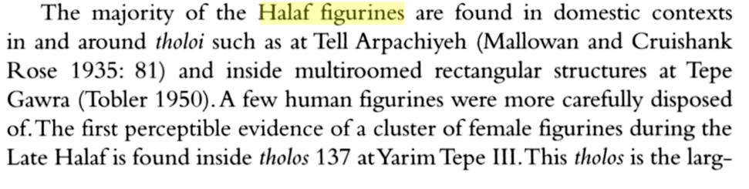
LC Classification: DS39.T38
Date or Time Horizon: 6000-5400 BCE
Geographical Area: Northern Syria
Map:
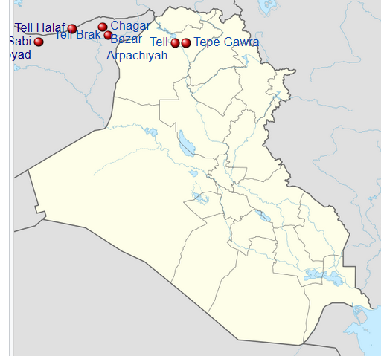
Map of Iraq showing important sites that were occupied during the Halaf culture . After https://upload.wikimedia.org/wikipedia/commons/thumb/8/80/Iraq_adm_location_map.svg/600px-Iraq_adm_location_map.svg.png

Tell Halaf
Tell Brak
Tell Sabi Abyad
Tell Arpachiyah
Tepe Gawra
Chagar Bazar
GPS coordinates: 36.8266°N 40.0396°E
Cultural Affiliation:
Medium: terracotta
Dimensions:
Weight:
Condition:
Provenance:
Discussion:

Tell Halaf (Arabic: تل حلف‎) is an archaeological site in the Al Hasakah governorate of northeastern Syria, near the Turkish border, just opposite Ceylanpınar. It was the first find of a Neolithic culture, subsequently dubbed the Halaf culture, characterized by glazed pottery painted with geometric and animal designs. The site, which dates to the 6th millennium BCE, was a Hittite ruling city at first and was later the location of the Aramaean city-state of Guzana or Gozan in the 10th century BCE. By the end of 9th century BCE the city and its surrounding area was incorporated into the Assyrian Empire.
A formerly unknown transitional culture between the pre-Halaf Neolithic's era and Halaf's era was uncovered in the Balikh valley, at Tell Sabi Abyad (the Mound of the White Boy).
Currently, eleven occupational layers have been unearthed in Sabi Abyad. Levels from 11 to 7 are considered pre-Halaf; from 6 to 4, transitional; and from 3 to 1, early Halaf. No hiatus in occupation is observed except between levels 11 and 10.^{[5]} The new archaeology demonstrated that Halaf culture was not sudden and was not the result of foreign people, but rather a continuous process of indigenous cultural changes in northern Syria,^{[7]} that spread to the other regions.^{[1]}
References:

Akkermans, Peter M. M. G.; Schwartz, Glenn M. (2003). The Archaeology of Syria: From Complex Hunter-Gatherers to Early Urban Societies (c.16,000-300 BC). Cambridge University Press.
Campbell, S. 2000. "The Burnt House at Arpachiyah: A Reexamination" Bulletin of the American Schools of Oriental Research no. 318
• • Castro Gessner, G. 2011. "A Brief Overview of the Halaf Tradition" in Steadman, S and McMahon, G (eds.) The Oxford Handbook of Ancient anatolia. Oxford: Oxford University Press. pp. 780
• • Castro Gessner, G. 2011. "A Brief Overview of the Halaf Tradition" in Steadman, S and McMahon, G (eds.) The Oxford Handbook of Ancient anatolia. Oxford: Oxford University Press. pp. 781
Liverani, Mario (2013). The Ancient Near East: History, Society and Economy. Routledge.
• • Maria Grazia Masetti-Rouault; Olivier Rouault; M. Wafler (2000). La Djéziré et l'Euphrate syriens de la protohistoire à la fin du second millénaire av. J.C, Tendances dans l'interprétation historique des données nouvelles, (Subartu) - Chapter : Old and New Perspectives on the Origins of the Halaf Culture by Peter Akkermans. pp. 43–44.
• • John L. Brooke (2014). Climate Change and the Course of Global History: A Rough Journey. p. 204.
• • Georges Roux (1992). Ancient Iraq. p. 101.
• • Susan Pollock; Reinhard Bernbeck (2009). Archaeologies of the Middle East: Critical Perspectives. p. 190.
• • Peter M. M. G. Akkermans, Glenn M. Schwartz (2003). The Archaeology of Syria: From Complex Hunter-Gatherers to Early Urban Societies (c.16,000-300 BC). p. 157.
• Robert J. Speakman; Hector Neff (2005). Laser Ablation ICP-MS in Archaeological Research. p. 128

Order details
Printer friendly page

Sales order
Sold by coinauction12 ( 5855 )
+ Show additional actions

Delivery package 1 of 1
Estimated delivery Friday, May 20, 2016 - Thursday, May 26, 2016
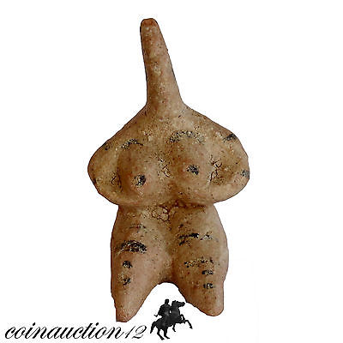

MUSEUM QUALITY TERRACOTTA TEL HALF FEMALE STATUE IDOL 6100-5400 BC
Item price | GBP 65.00
Quantity | 1
Item number | 391452373433
Shipping service | Royal Mail International Signed
Contact seller
Return item

Shipping address

Ralph J Coffman Jr
149 Atlantic Ave
Swampscott MA 01907-2427
United States

Order total

Subtotal | GBP 65.00
Shipping | GBP 9.99
Total
GBP 74.99
View PayPal transaction

Order placed on
Monday, May 16, 2016
Payment method
PayPal
Payment date
Monday, May 16, 2016

